Company logo

|  |  |
| --- | --- |
| **Title:** | Regulatory plan for XXX |
| **Document number:** |  |
| **Version (date):** |  |
| **Sponsor:** | Company name  Address |

Property of Company Name   
Confidential

Regulatory plan amendment history

Document history

|  |  |
| --- | --- |
| **Protocol version** | **Date** |
| Amendment N | DD-Mmm-YYYY |
| Amendment N-1 | DD-Mmm-YYYY |
| … | DD-Mmm-YYYY |
| Amendment 1 | DD-Mmm-YYYY |
| Original | DD-Mmm-YYYY |

Amendment N (DD-Mmm-YYYY)

Amendment rationale

Changes to the previous version of the regulatory plan

Amendment N-1 (DD-Mmm-YYYY)

Amendment rationale

Changes to the previous version of the regulatory plan

Amendment 1 (DD-Mmm-YYYY)

Amendment rationale

Changes to the previous version of the regulatory plan

Table of contents

Regulatory plan amendment history 2

Document history 2

Amendment N (DD-Mmm-YYYY) 2

Amendment N-1 (DD-Mmm-YYYY) 2

Amendment 1 (DD-Mmm-YYYY) 2

List of figures 4

List of tables 5

List of abbreviations 6

1. Product definition and target product profile 7

1.1. Product definition 7

1.2. Target product profile 7

2. Primary target indication 8

2.1. Orphan status, prevalence & incidence 8

2.2. Justification for choice of treatment line 8

2.3. Countries for clinical development 8

3. Other potential indications 9

4. Early interaction with regulatory agencies 10

4.1. Scientific advice with EMA 10

4.2. US FDA 10

4.3. Japan and other regions 10

4.4. Local scientific advice 10

5. Paediatric plan 11

5.1. EU paediatric investigation plan (PIP) 11

5.2. US pediatric plan (PSP) 11

5.3. Commonalities between EU PIP and US PSP 11

6. PRIME designation 12

7. Breakthrough designation 13

8. Real-time oncology review (RTOR) 14

9. Interaction during and after phase 2 15

9.1. EU joint CAT-HTA scientific advice 15

9.2. US EOP2 15

10. Regulatory action plan 16

11. References 17

12. Appendices 18

12.1. Target product profile 18

12.2. Clinical trial application tracker 18

List of figures

**No table of figures entries found.**

No numbered figure in the document

List of tables

No numbered table in the document

List of abbreviations

| **Acronym** | **Definition** |
| --- | --- |
|  |  |
|  |  |
|  |  |
|  |  |

# Product definition and target product profile

## Product definition

***Instructions:*** *Provide a clear definition for the product for which a regulatory plan is proposed. This definition is then to be used in any other document where the product definition is to be provided.*

## Target product profile

***Instructions:*** *Provide high level information about the target product profile and refer to the appendix with the detailed information about the target product profile.*

# Primary target indication – Indication 1

## Description of the primary target indication

***Instructions:*** *Provide a description of the target indication. This will influence the intended population to target in the clinical trials.*

## Orphan status, prevalence & incidence

***Instructions:*** *Provide within the major region the information with regards to the prevalence and incidence and indicate for the decision with regards to orphan designation potential with the major regions.*

## Justification for choice of treatment line

***Instructions:*** *Provide the justification for the choice of the target indication and the choice of the line.*

## Countries for clinical development

***Instructions:*** *Provide the intended list of countries for clinical development, supplemented with justification. Refer to the appendix on the status of the clinical trial applications.*

# Other potential indications

***Instructions:*** *Repeat Section 2 for the other potential indications of interest*

# Early interaction with regulatory agencies

## Scientific advice with EMA

***Instructions:*** *List the expected trigger for the scientific advice, the type of preparation, the timelines, the topics to be covered and the target in term of position to be reached.*

## US FDA

***Instructions:*** *List the expected trigger for the interaction advice, the type of preparation, the timelines, the topics to be covered and the target in term of position to be reached.*

## Japan and other regions

***Instructions:*** *List the expected trigger for the interaction, the type of preparation, the timelines, the topics to be covered and the target in term of position to be reached.*

## Local scientific advice

***Instructions:*** *List the expected trigger for the interaction, the type of preparation, the timelines, the topics to be covered and the target in term of position to be reached.*

# Paediatric plan

## EU paediatric investigation plan (PIP)

***Instructions:*** *Please provide if there is any reason to request a waiver. List the expected trigger for the interaction, the type of preparation, the timelines, the topics to be covered and the target in term of position to be reached.*

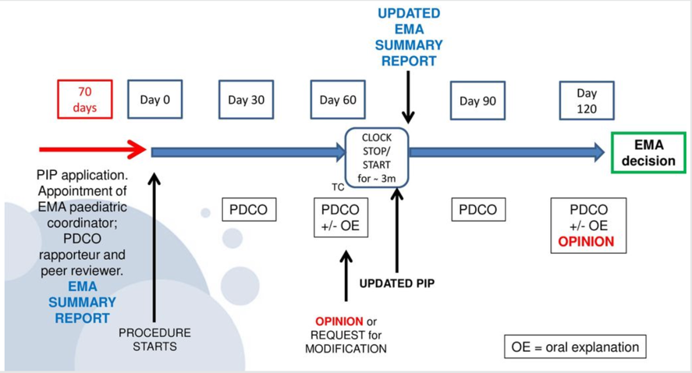

## US pediatric plan (PSP)

***Instructions:*** *An initial pediatric study plan is to submitted, regardless of whether the drug is for an orphan designation. List the expected trigger for the interaction, the type of preparation, the timelines, the topics to be covered and the target in term of position to be reached.*

## Commonalities between EU PIP and US PSP

***Instructions: List the commonalities between the EU PIP and the US PSP***

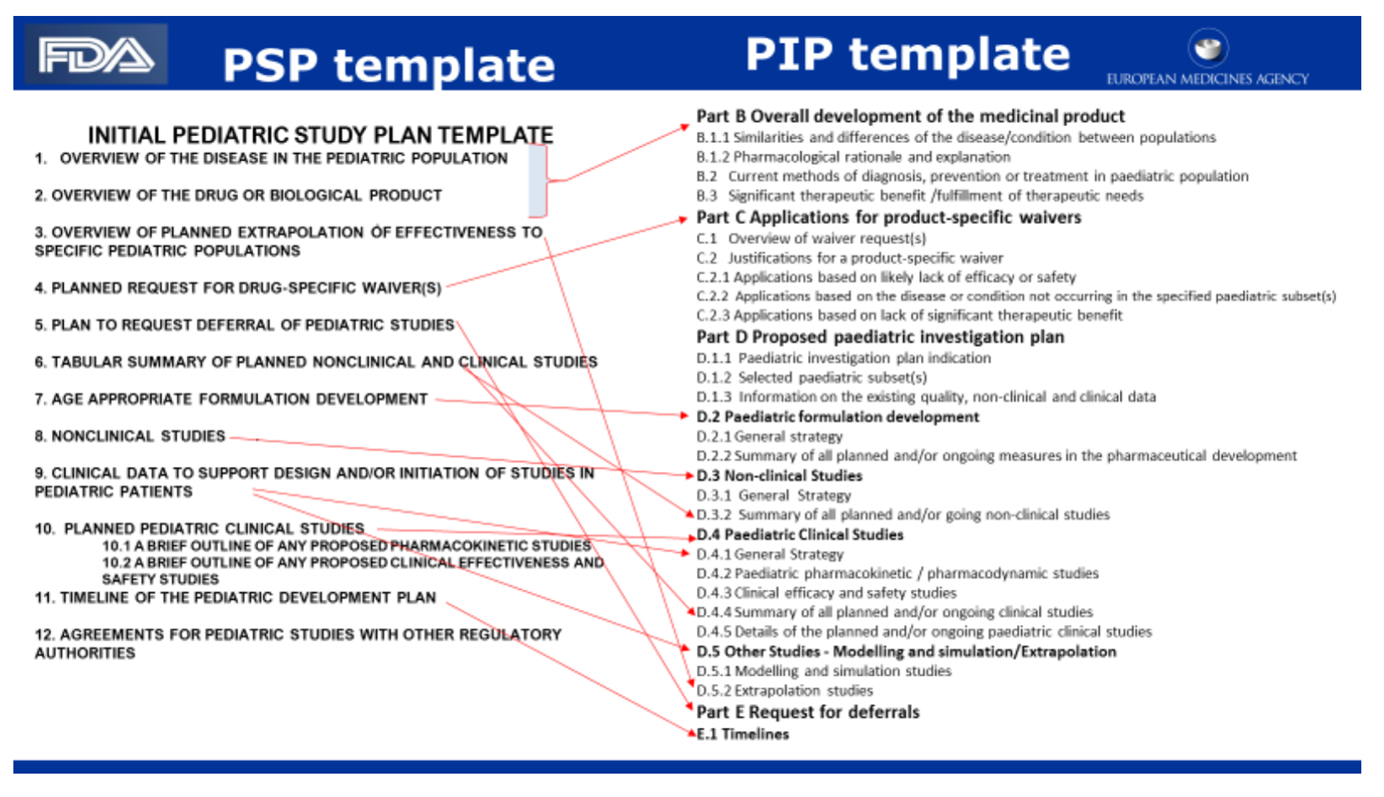

## Paediatric plan in other regions

# PRIME designation

***Instructions:*** *Adapt based on the phase 1 or phase 2 results the decision for a PRIME designation. Verify if the candidate medicinal product can be considered as a candidate for a PRIME designation. List the pros, cons, the expected trigger for the interaction, the type of preparation, the timelines, the topics to be covered and the target in term of position to be reached.*

# Breakthrough designation

***Instructions:*** *Adapt based on the phase 1 or phase 2 results the decision for a breakthrough designation. Verify if the candidate medicinal product can be considered as a candidate for a breakthrough designation. List the pros, cons, the expected trigger for the interaction, the type of preparation, the timelines, the topics to be covered and the target in term of position to be reached.*

# Real-time oncology review (RTOR)

***Instructions:*** *Request is to be done at the time of the BLA submission.*

# Interaction during and after phase 2

## EU joint CAT-HTA scientific advice

***Instructions:*** *Complete as relevant.*

## US EOP2

***Instructions:*** *Complete as relevant.*

# Regulatory action plan

***Instructions:*** *CProvide a table with the region/agency, the milestone, the target date for final position of the agency, the meeting request, the date for the briefing book to be submitted. For the EMA, the following elements can be expected: SME status, orphan disease, protocol assistance, scientific advice on development plan, PRIME designation, CAT-HTA parallel SA meeting, Pre-MAA, MAA submission. For the US FDA, the following elements can be expected: Pre-IND meeting, orphan designation, IND submission, breakthrough / fast track designation, type C, EOP2, pre-BLA , BLA.*

# References

***Instructions:*** *List in this section any reference use over the document.*

# Appendices

## Target product profile

***Instructions:*** *In a tabular format, list as relevant the information related to the target product profile. The template from the US FDA prescribing information and/or EMA product information template can be used.*

## Clinical trial application tracker

***Instructions:*** *In a tabular format, list the status of the clinical trial applications.*